**THREAD PARAMETER PASSING AND RETURN HANDLING**

**1. Create a multithreaded program to**

**a. read 3 lines as a single command line argument**

**b. extract every line and pass it to a thread.**

**c. each thread should sort all the words in the line in ascending order and return sorted line to the main thread**

**d. main thread to wait for all child threads to complete, then read and display the sorted line ”.**

**e. Release any allocated memory**

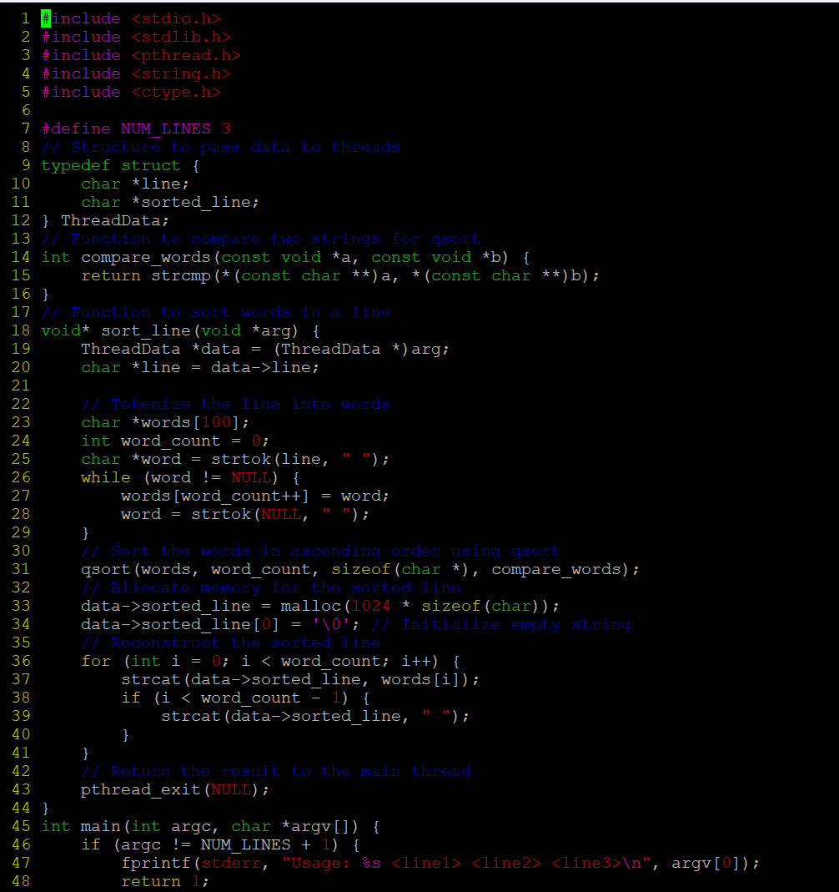

**OUTPUT:**



**2. Write a program to read a file name, to read lines , process it using two or more threads (i.e one thread/line) to count and display the words in the line. For this implement functions below, integrate and test solution.**

**//receive thread count as argument, create an array of pthread_t (double pointer allocated memory in heap) and return pointer**

**a) createthreads()**

**//to receive filename, thread array as args, process each line using a thread function**

**b) process_file()**

**//receive a line as input, count words and display, return line and word count to parent thread in a structure**

**c) thread_proc()**

**Ensure that there are no memory leaks**

**OUTPUT:**

